Annotation de la preuve OCR

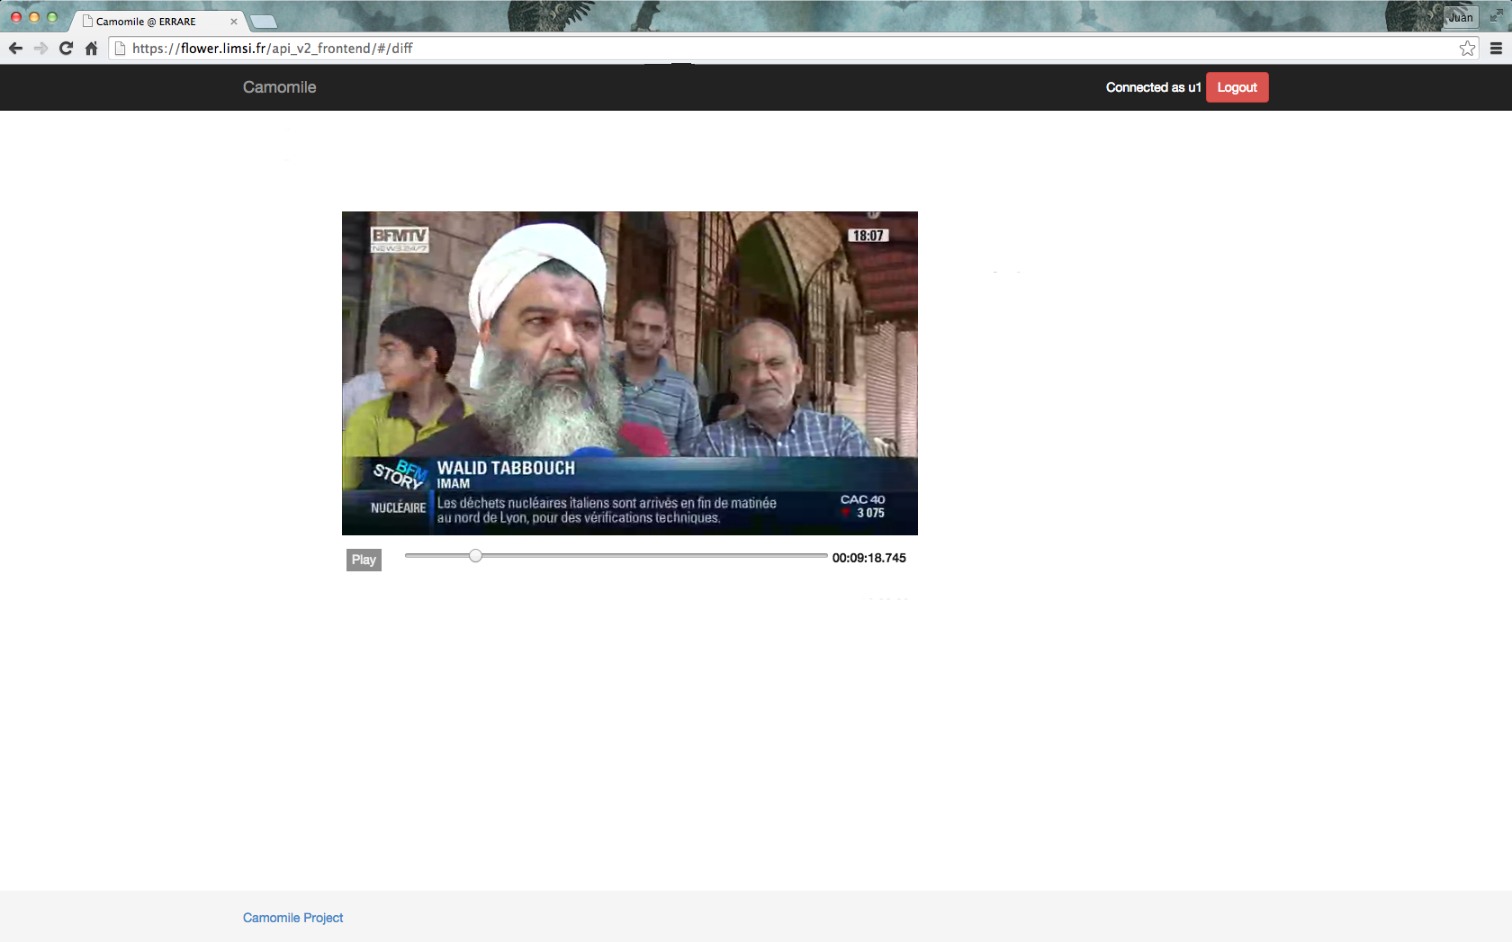

- Correct the name if need.

- Click on the face (you can play the video to find a better image).

- Valid your annotation.

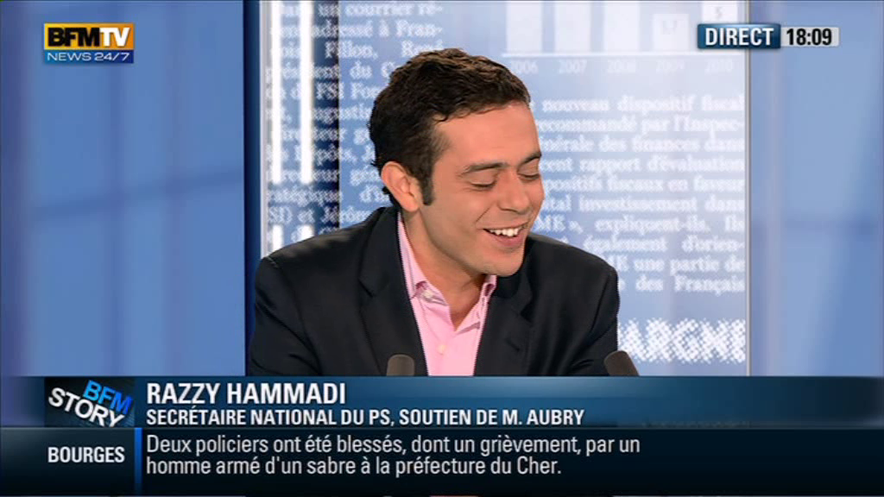

RAZZY HAMMADI

Annotation de la preuve ASR

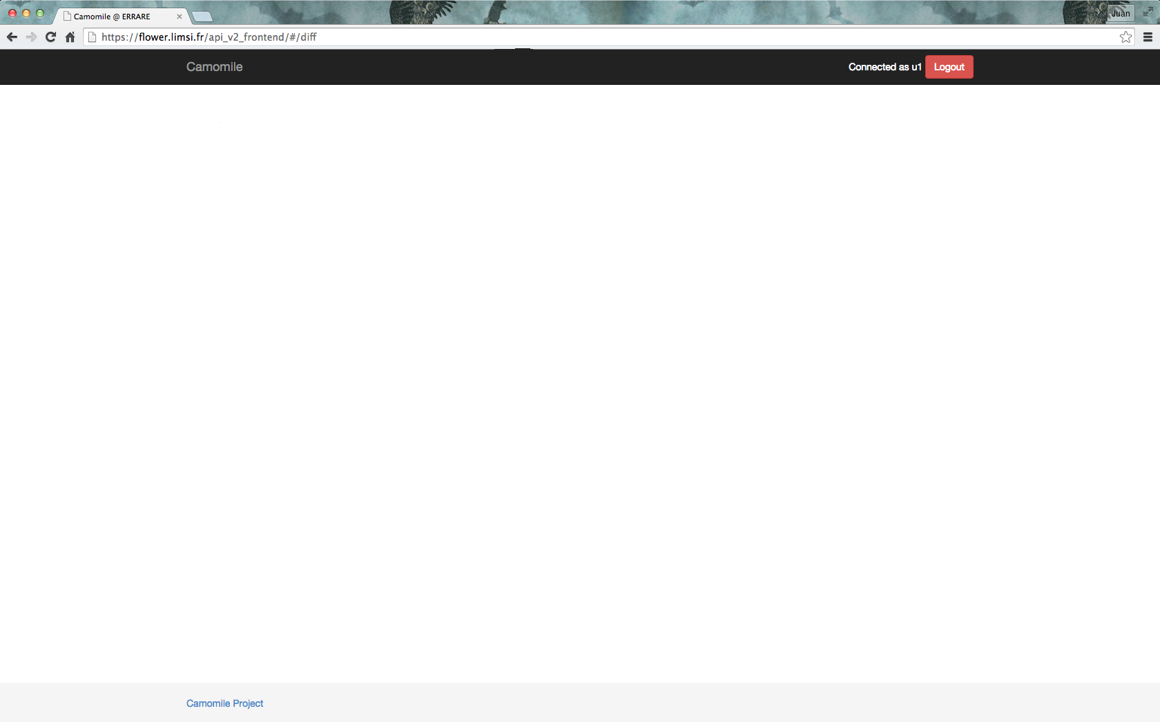

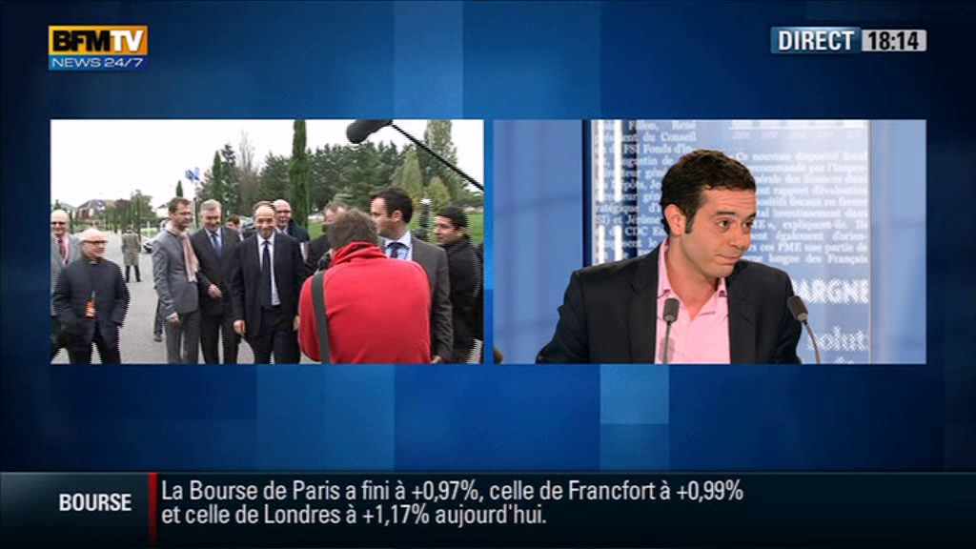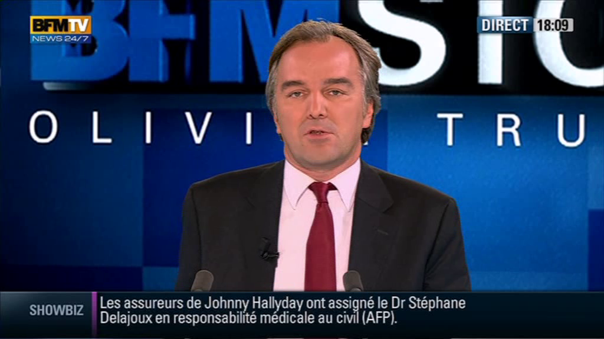Annotation des visages

- Correct the name if need.

- Click on the face in the video et the left side (you can play the video to find a better image).

- Valid your annotation.

RAZZY HAMMADI

… Bienvenue « Razzy Hammadi », vous êtes le secretaire nationnal du PS …



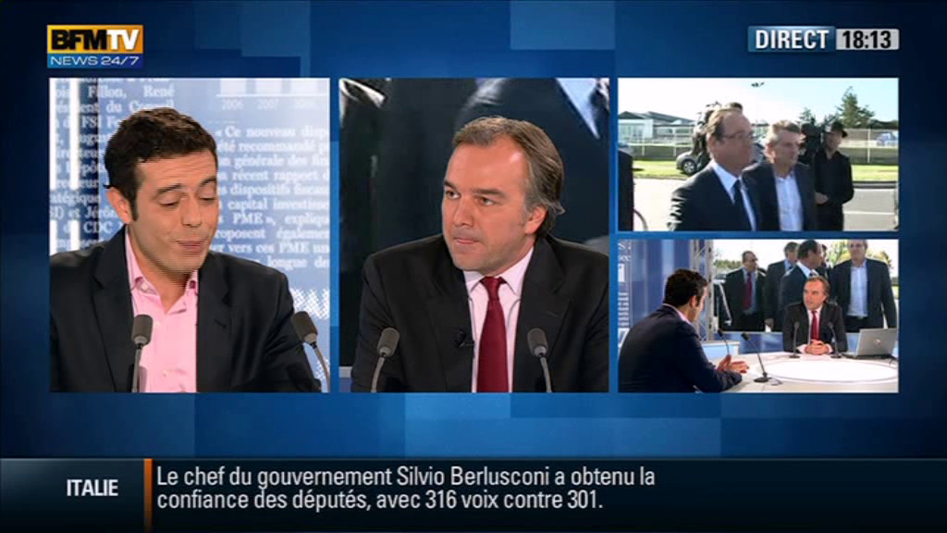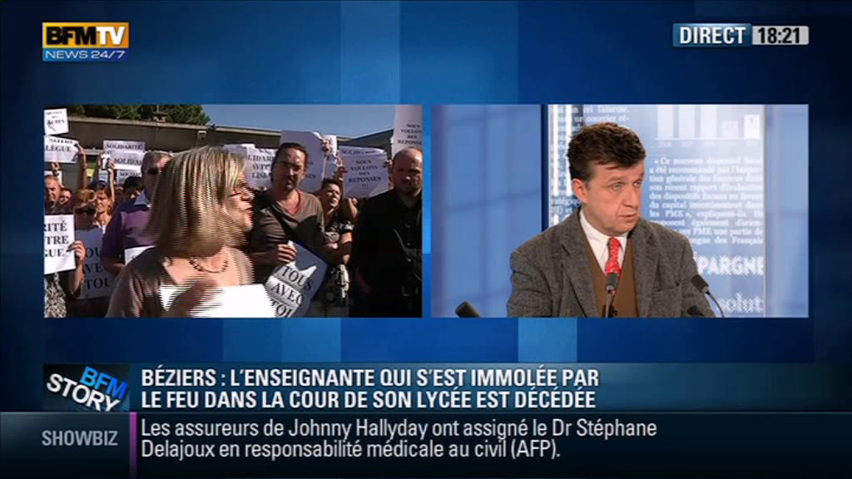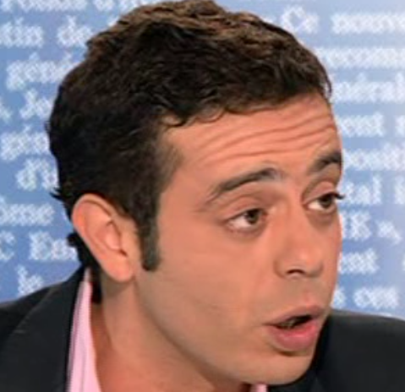’

Move on the left:

* once if the person appearing
* twice is also speaking

Clic on question mark if an other person is speaking and appearing and select the good image or the question mark

Annotation des visages



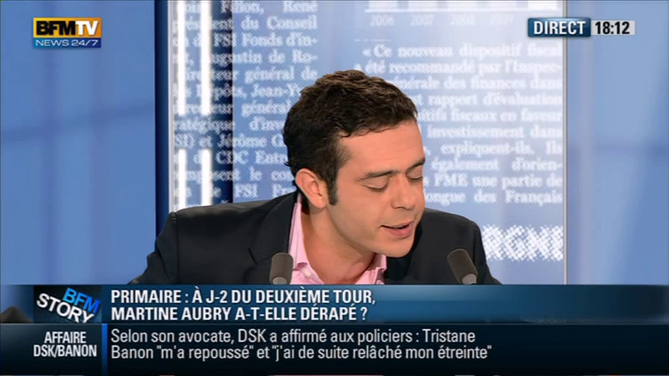

Click on the face of the same person in the video at the left side

Annotation visage parlant





- Is the face surrounded speaks in the shot